**Quiz for Java Programming** (Tutor: cyd@bupt.edu.cn)

Unit 01 Unit01-Fundamentals of Java Programming

1. Java virtual machine is a software to interpret byte code
2. (T/F) JavaDoc style comments can be put into a function body
3. The main method must be public and static in case it is called without initializing an instance of the class which it resides.

**编程题**：注意以下题目应使用 git 工具管理代码，需将代码托管到老师指定的网站中（可能是 gitee、阿里云效或者 github 等之一）。你的代码仓库必须设置为私有。

1. Write a program to print a message. Then 1) build and run the program in the IDE; 2) run the program in a command shell; 3) compile or build the program in a command shell. Write down your command line. (Attention: do NOT use package keyword in your program)

1)

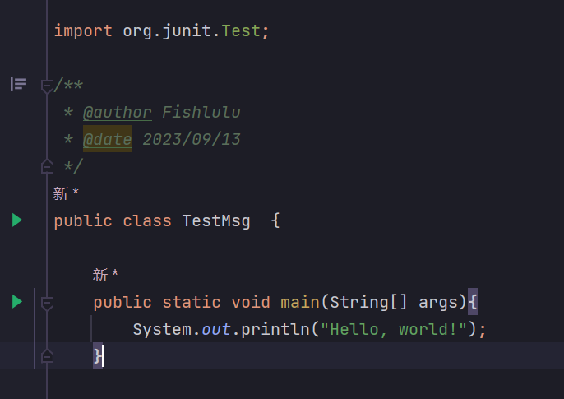

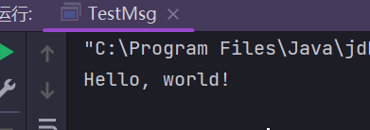

2) 3)

1. Read the textbook sections or slides for "package and classpath". Modify your program in Quiz 4 to use the "package" keyword. Do steps 1)-3) in Quiz 4 to see the results. Write down your command line.



1. Write a program to compute the sum of 1,2,...10 and output the result. 1) use while statement; 2) use do...while statement; 3) use a general for statement; 4) use a for each statement (like c++11 range-based for loop)

1) 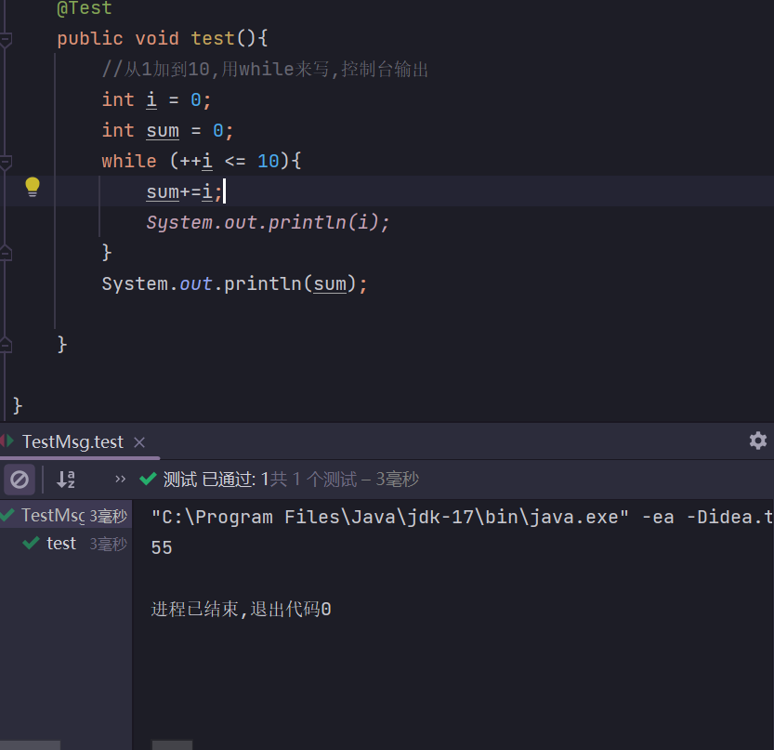

2) 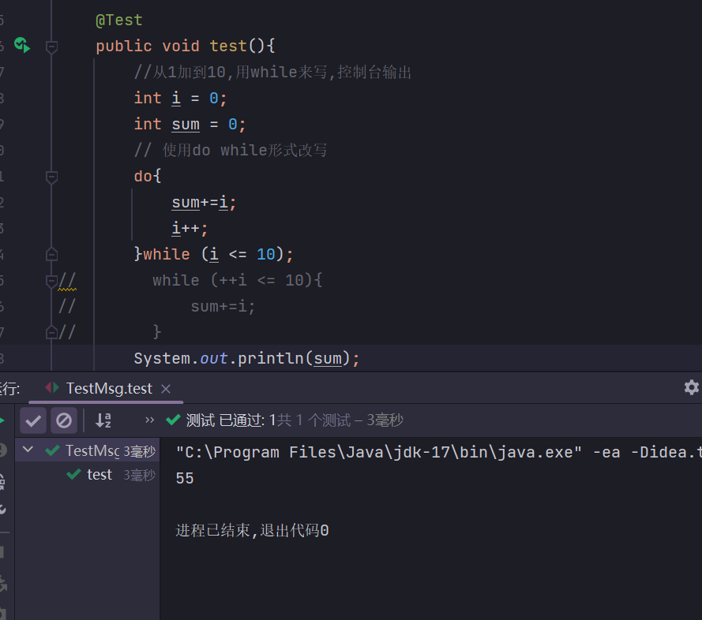

3)

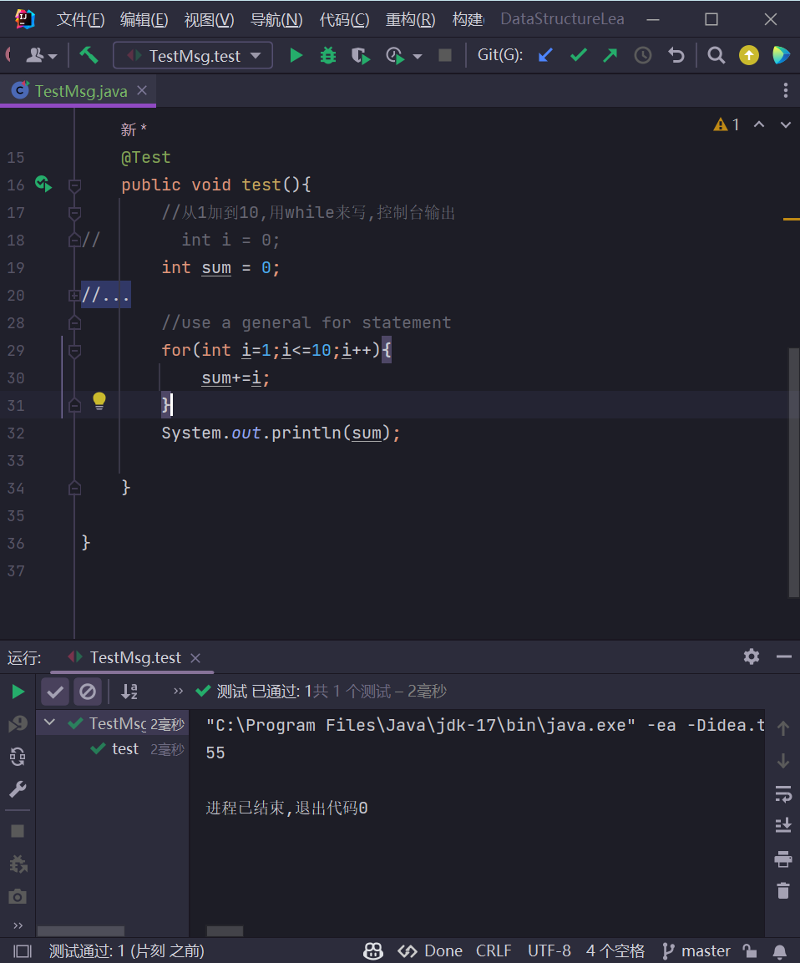

4) 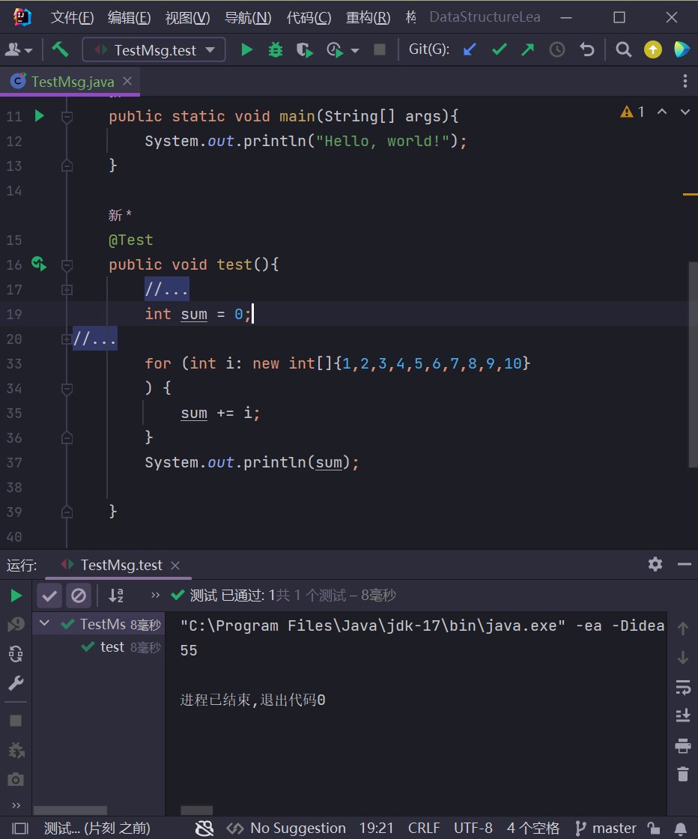

1. Try using the IDE debugging ways of "breakpoint/step-in/step-over/..." to check the status when it comes to the adder number of 5 in Quiz 6. Write down your operations.

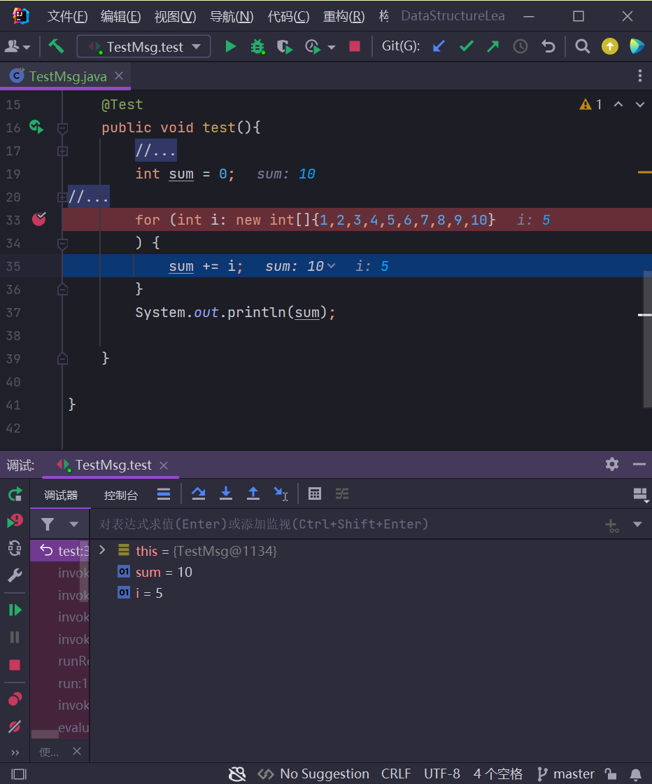

Run the Unit test with debugging mode,then press f8 to step over until I = 5;

1. Write some overloading functions, which will output the data types of the following data: 3.5, 3.50, 0.0, 0, 0., 3d, 3f, 3, 'c'

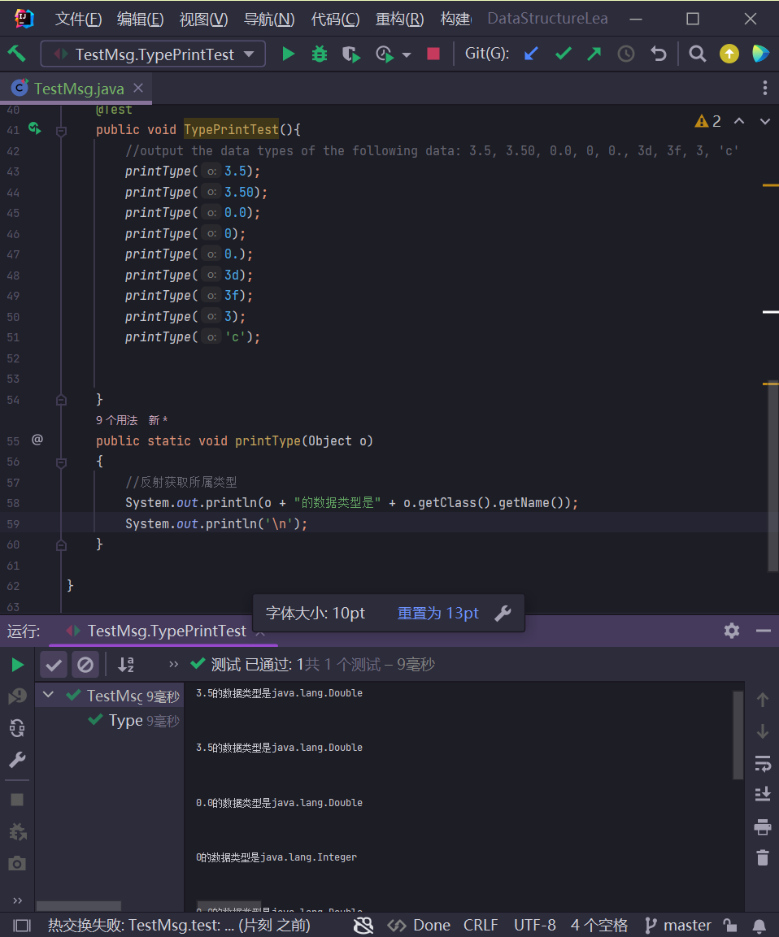

1. 用 java 库中的 Math.random 生成整数：1) 10 个不大于 100 的非负整数，可重复；

2) 10 个不大于 10 的非负整数（即顺序随机的 0-9 个数字），将结果输出。

1)2)

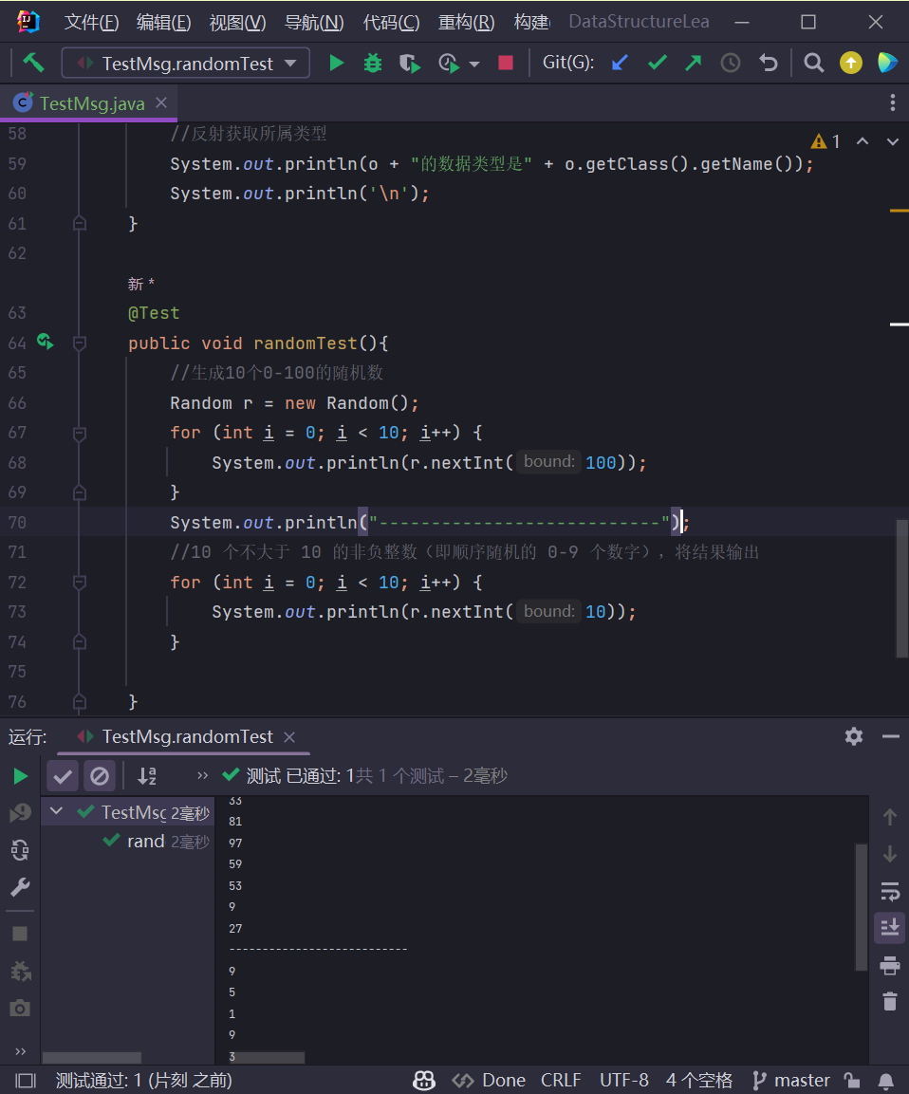

1. 编写一个冒泡法排序函数，在主函数中调用该排序函数，将 Quiz 9 中生成的 10

个整数放入数组 arr 中，然后按从小到大的次序排序并输出。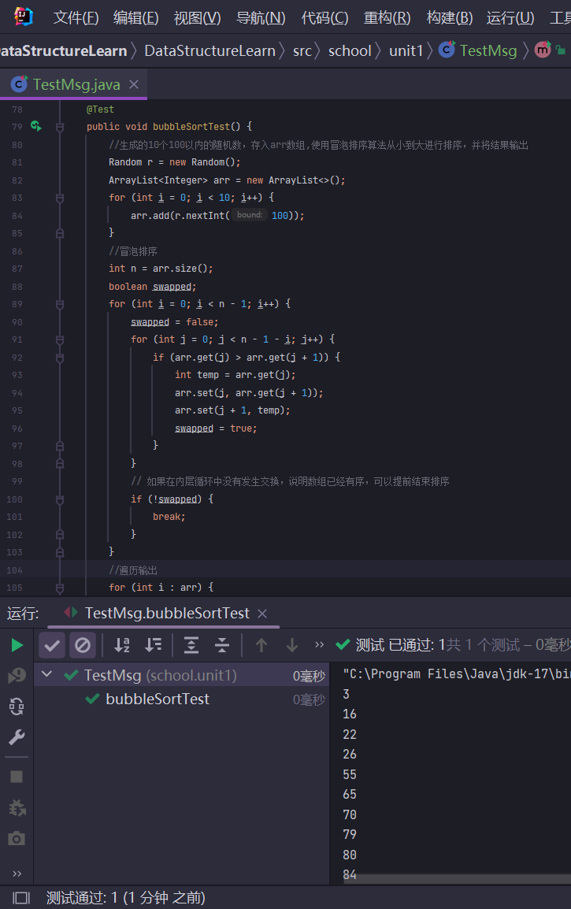

1. 使用 java 绘制一条正弦曲线。自行确定所需绘制的坐标范围。绘图库可以参考：

<https://gitee.com/bupt-se/JavaPlot.git>（或 <https://github.com/sintrb/JavaPlot>）。也可自选其它绘图库或绘图方式。